
FLORIDA STATE UNIVERSITY
FAMU-FSU College of Engineering
Department of Chemical and Biomedical Engineering
HEAVY AND EXTRA HEAVY CRUDE OILS:
Integrated Selection of Recovery, Transportation,
Partial Upgrading, and Refinery Processing Pathways

Final Project Report

Submitted by:
Vinay Chintala
ABSTRACT
Heavy and extra heavy crude oils occupy an important place in the future hydrocarbon supply mix, but they remain among the most difficult petroleum resources to produce, transport, and refine. Their low API gravity, very high viscosity, elevated asphaltene content, and relatively high sulfur, nitrogen, metals, and Conradson carbon residue mean that the engineering problem cannot be solved at a single stage of the value chain [1], [2]. The recovery method chosen in the reservoir changes the surface facilities required, the transportation strategy, the extent of field upgrading, and the burden placed on the refinery [3], [4]. This report treats heavy oil as an integrated reservoir-to-refinery system rather than as an isolated production problem.
The study reviews cold production, steam-based thermal recovery, solvent-assisted processes, in-situ combustion, emerging electromagnetic and catalytic approaches, midstream flow-improvement methods, and downstream upgrading routes [4]-[8]. A three-gate decision logic is proposed: reservoir feasibility, surface-logistics feasibility, and refinery compatibility. To make this framework quantitative, a weighted Integrated Suitability Score (ISS) equation is developed and demonstrated across three contrasting engineering scenarios. The analysis shows that no single technique is universally superior. Cold Heavy Oil Production with Sand (CHOPS) remains attractive in shallow unconsolidated reservoirs with foamy-oil behavior [4]. Steam-based methods, especially Steam-Assisted Gravity Drainage (SAGD) and its solvent-assisted variants, remain the strongest choices for deep, thick, laterally continuous bitumen reservoirs [7], [9]. Partial upgrading becomes particularly valuable when diluent supply, export logistics, or refinery residue limits control project economics [3], [5].
The main contribution of this report is a practical screening framework that links recovery selection to transportation constraints and refinery conversion capability. This makes the report more useful for process, production, and refinery-oriented petroleum engineering decisions than a descriptive literature summary alone.

Keywords: Heavy crude oil; extra-heavy oil; bitumen; SAGD; CHOPS; solvent-assisted recovery; partial upgrading; refinery integration; pipeline transportation; three-gate framework; Integrated Suitability Score.

TABLE OF CONTENTS
ABSTRACT 2
LIST OF FIGURES 6
LIST OF TABLES 7

1. INTRODUCTION 8
2. SCOPE AND OBJECTIVES 10
2.1 Objectives 10
2.2 Scope 10
2.3 Research Gap Addressed 10
3. LITERATURE REVIEW 11
4. CLASSIFICATION AND ENGINEERING BEHAVIOR OF HEAVY OILS 15
4.1 API Gravity Classification 15
4.2 Viscosity and Temperature Dependence 15
4.3 SARA Composition and Contaminants 16
5. RECOVERY TECHNOLOGIES AND SELECTION WINDOWS 18
5.1 Cold Production and CHOPS 18
5.2 Cyclic Steam Stimulation (CSS) 18
5.3 Steam-Assisted Gravity Drainage (SAGD) 18
5.4 Solvent-Assisted SAGD and ES-SAGD 19
5.5 VAPEX and Solvent-Dominant Methods 19
5.6 In-Situ Combustion, THAI, and CAPRI 19
5.7 Emerging Hybrid Technologies 20
6. TRANSPORTATION AND FLOW ASSURANCE 22
6.1 Dilution and Dilbit 22
6.2 Heated Pipelines 22
6.3 Emulsification and Core-Annular Flow 22
6.4 Partial Upgrading for Transport 23
7. UPGRADING TECHNOLOGIES 25
7.1 Carbon-Rejection Routes 25
7.2 Hydrogen-Addition Routes 25
8. REFINERY PROCESSING IMPLICATIONS 28
9. INTEGRATED THREE-GATE SELECTION FRAMEWORK 30
9.1 The Three Gates 30
9.2 Integrated Suitability Score (ISS) Equation 30
10. SCENARIO-BASED APPLICATION 32
10.1 Case A: Shallow Unconsolidated Heavy Oil 32
10.2 Case B: Deep Thick Bitumen with Continuous Pay 33
10.3 Case C: Remote Transport-Limited Heavy Crude 33
11. KEY FINDINGS AND DISCUSSION 34
12. CONCLUSION 36
13. LIMITATIONS 37
14. FUTURE DIRECTIONS 38
15. REFERENCES 39

LIST OF FIGURES
Figure 1. Practical classification map for heavy and extra-heavy crude oils 15
Figure 2. Temperature dependence of viscosity for each crude category 16
Figure 3. SAGD well pair configuration and steam chamber schematic 20
Figure 4. CHOPS wormhole schematic and recovery factor ranges 21
Figure 5. Process flow diagram of three heavy-oil transport pathways 23
Figure 6. Process flow diagram of two heavy-oil upgrading pathways 26
Figure 7. Heavy crude refinery integration pathway 28
Figure 8. Three-gate reservoir-to-refinery selection framework 30
Figure 9. Three-gate decision tree for three project archetypes 32
Figure 10. Energy and carbon flow in SAGD production 34

LIST OF TABLES
Table 1. Fluid properties that control heavy-oil handling and processing 17
Table 2. Comparison of major heavy-oil recovery routes 21
Table 3. Main transportation routes for heavy and extra-heavy crude oils 24
Table 4. Upgrading pathways and their main use cases 27
Table 5. Suggested weights for the Integrated Suitability Score 31
Table 6. Outcomes from the three-gate screening framework 33

1. INTRODUCTION
Heavy and extra-heavy crude oils are not niche feeds; they represent one of the largest remaining hydrocarbon resource bases available to industry [1], [15]. At the same time, they are among the least forgiving resources from an engineering standpoint. Compared with conventional crudes, these feeds exhibit lower API gravity, much higher viscosity, stronger non-ideal behavior due to resins and asphaltenes, and a greater tendency to create fouling, deposition, emulsion, sulfur-handling, and residue-conversion problems [1], [3]. For these reasons, heavy-oil development cannot be treated only as a reservoir problem. It is equally a heat-transfer problem, a phase-behavior problem, a transport problem, a catalyst-management problem, and a refinery-configuration problem.
The global petroleum industry is in a clear transition. The conventional light sweet crude oils that powered the last century of refining are increasingly difficult to find and more costly to produce. What remains in abundance are the heavy crudes, oil sands, and bitumen deposits that were long considered too difficult to develop. According to the United States Geological Survey, the Orinoco Heavy Oil Belt in Venezuela alone contains an estimated 513 billion barrels of technically recoverable oil [15], and the Government of Alberta reports recoverable oil sands reserves of approximately 165 billion barrels [16]. These resources are not academic curiosities; they represent the feedstock reality that the refining industry will face for the next several decades.
A production method that raises recovery but creates an unstable export blend, excessive diluent dependence, or an unmanageable vacuum-residue burden at the refinery may not be the best practical choice. This report is built around that missing link. Its central question is not simply how heavy oil can be produced, but rather how heavy oil should be produced, transported, upgraded, and refined as one connected system.
In industrial practice, heavy-oil value is determined not only by reservoir deliverability but also by bottom-of-the-barrel conversion, hydrogen availability, sulfur recovery capacity, metals tolerance, and the economics of diluent and fuel gas [3], [10]. This integrated viewpoint makes the topic especially useful for a petroleum engineering student who seeks to understand how upstream and downstream decisions interact.
Gate 1 addresses reservoir feasibility, Gate 2 addresses surface-logistics feasibility, and Gate 3 addresses refinery compatibility. The framework is operationalized through an Integrated Suitability Score (ISS) equation that allows weighted ranking of candidate pathways. The framework is demonstrated across three representative scenarios that show how the preferred method changes dramatically depending on reservoir, logistics, and refinery context.

2. SCOPE AND OBJECTIVES

2.1 Objectives
The first objective is to classify heavy and extra-heavy crude oils in terms of the fluid properties that matter most in practice: API gravity, viscosity, SARA composition, contaminant loading, and temperature sensitivity. The second objective is to evaluate the main recovery routes, including cold production, thermal methods, solvent-assisted strategies, combustion methods, and emerging technologies, and to identify the selection windows where each method is appropriate. The third objective is to compare transportation and upgrading options as integral parts of the value chain rather than treating them as afterthoughts. The fourth objective is to develop a practical three-gate selection framework that connects reservoir conditions to surface-logistics feasibility and to refinery-conversion compatibility.

2.2 Scope
The scope of this project covers the full petroleum value chain relevant to heavy and extra-heavy oils: reservoir recovery mechanics, pipeline transport and flow assurance, field and refinery upgrading, and downstream conversion logic. The report does not claim to be a full reservoir simulation, a detailed plant design, or a refinery linear programming (LP) optimization study. It is a structured technical screening and selection study grounded in the peer-reviewed literature.

2.3 Research Gap Addressed
A common weakness on heavy oil is that they remain descriptive rather than analytical. Even when multiple technologies are listed, this rarely explain when each method should be preferred or rejected under specific project conditions. This addresses that gap by building selection logic into the structure of the review and by producing a quantitative scoring framework that can be recalibrated for different priorities.

3. LITERATURE REVIEW
This synthesizes spanning reservoir engineering, midstream logistics, petroleum processing, and refinery operations. It is an integrated approach that reflects a critical gap in the academic and professional literature. The motivation for this integrated framework emerges from analyzing how existing studies compartmentalize heavy-oil development decisions.
Knowledge Gap and Project Motivation
The existing literature on heavy-oil recovery is voluminous, but it is predominantly organized into discipline-specific sub-domains. Reservoir engineers publish on recovery mechanisms in isolation; transport specialists optimize pipelines without full knowledge of upstream recovery choices; refinery engineers assess feed compatibility without direct input from producers. This fragmentation creates a recurring industrial failure mode: technically sound recovery methods that generate unmarketable crude, transportable blends that the refinery cannot process efficiently, or optimal refinery configurations that ignore upstream constraints. The research gap addressed here is therefore not a lack of technical knowledge about individual components, but rather the absence of an integrative selection framework that makes explicit how recovery selection, transportation strategy, upgrading severity, and refinery configuration interact to determine project success.
Classification, Properties, and Engineering Behavior of Heavy Oils
The foundational work of Santos et al. [1], Martinez-Palou et al. [2], and Guo et al. [4] establishes the physical and chemical characteristics that distinguish heavy and extra-heavy oils from conventional crudes. The key finding is that API gravity, while useful as a screening metric, is insufficient for complete characterization. Two oils with identical API gravity can exhibit dramatically different behavior if asphaltene, resin, sulfur, and metals concentrations differ [1], [3]. The SARA (Saturates, Aromatics, Resins, Asphaltenes) compositional framework, combined with measurements of viscosity temperature dependence and heteroatom content, provides the basis for engineering decisions about heat requirements, hydroprocessing severity, and residue-conversion strategy [3]. Rana et al. [3] critically synthesizes how these properties control the choice between hydrogen-addition and carbon-rejection upgrading strategies. The temperature dependence of viscosity is particularly significant: the exponential relationship between viscosity and inverse absolute temperature means that relatively modest heat inputs can mobilize oils that would otherwise require massive energy investments [4]. This observation justifies the prominence of thermal methods in the literature and forms the technical basis for the recovery-method selection.
Recovery Technologies and Mechanism-Based Selection
The literature distinguishes recovery methods by the physical or chemical mechanism they exploit. Cold Heavy Oil Production with Sand (CHOPS) leverages geomechanical stress relief and foamy-oil behavior in unconsolidated formations; Guo et al. [4] shows that CHOPS recovery factors of 30–50 percent are achievable in reservoirs where this mechanism is present, but CHOPS is inapplicable in consolidated formations or where foamy-oil physics is weak. The three methods in Thermal methods are Cyclic Steam Stimulation (CSS), Steam-Assisted Gravity Drainage (SAGD), and emerging solvent-assisted variants, which dominate the literature on deep, thick bitumen because they exploit the viscosity-temperature relationship to mobilize immobile oil [4], [9]. SAGD is the commercial workhorse of oil sands development; Gates and Larter [9] rigorously quantify the energy penalty (steam-to-oil ratio of 3–6 barrels of steam per barrel of oil produced) and show that solvent co-injection can reduce this ratio to 2–3 barrels per barrel under favorable conditions. The critical finding across this body of work is that recovery method choice is not primarily a question of which method is best in the abstract, but rather which method matches the specific reservoir constraints: depth, thickness, lateral continuity, pressure regime, unconsolidation, heterogeneity, and pressure depletion history [4]. In-situ combustion and THAI/CAPRI processes are reviewed by multiple sources but have not achieved widespread commercial adoption [4], [11]. The literature on these methods consistently identifies operational challenges in combustion-front stability and oxygen management. However, the strategic importance of combustion-based approaches lies in their potential for simultaneous recovery and in-situ upgrading, which could become decisive in future carbon constrained environments.

Transportation and Midstream Flow Assurance
Martinez-Palou et al. [2], Hart [5], and Saniere et al. [13] provide comprehensive reviews of transportation strategies. The central finding is that viscosity management is the primary constraint. Dilution with light hydrocarbons (dilbit) is the most commercially mature method and dominates oil sands logistics [2] but creates a round-trip diluent-supply chain cost. Heated pipelines [5] remove the dilution burden but impose electrical or steam-driven heating costs that can be substantial at long distances. Emulsification and core-annular flow [14] offer viscosity reduction without diluent but require careful management of emulsion stability and add separation complexity downstream. The critical insight from this body of work is that transportation strategy must be chosen during reservoir development, not after production has begun, because recovery method choice constrains the properties of the produced crude and thus determines transportation requirements [2]. This interdependence directly motivates the integrated framework of this report.
Upgrading Pathways and Hydroprocessing Severity
Rana et al. [3] and Speight [17] comprehensively review upgrading technologies. The fundamental division is between carbon-rejection routes (visbreaking, delayed coking, solvent deasphalting) and hydrogen-addition routes (hydrotreating, hydrocracking, ebullated-bed conversion, slurry hydrocracking). Carbon rejection achieves rapid viscosity reduction and API improvement with no hydrogen requirement but produces coke or asphalt byproducts whose economics are increasingly challenged [3]. Hydrogen addition achieves higher liquid recovery (85–92 percent versus 70–80 percent for coking) but demands substantial hydrogen capacity and can be constrained by metals tolerance in catalyst systems [3]. Gray [18] and Castaneda et al. [24] extend this analysis to emerging approaches including supercritical water processing and dispersed-catalyst methods, though these remain pilot-scale technologies. The consensus finding across upgrading literature is that partial upgrading, modest viscosity and API improvement without full hydrotreating and it can be economically superior to both full crude-oil upgrading and dilution-only strategies when diluent supply or refinery residue-conversion capacity is constrained [3], [5].

Refinery Integration and Residue Conversion
The refinery implications of heavy-crude feeding are thoroughly reviewed by Speight [17], Gray [18], and are touched on by multiple upstream-focused sources [3], [10]. The critical finding is that heavy crude shifts the refinery economics dramatically. Atmospheric distillation of heavy crude yields 65–75 percent vacuum residue compared to 25–35 percent for light crude. This residue must be either coked, hydrocracked, or sold as fuel oil at a penalty. Every downstream unit has FCC, hydrocracker, hydrotreater, hydrogen reformer, sulfur-recovery unit must be scaled to handle heavy-crude properties: elevated nickel and vanadium. Which deactivate FCC catalysts, high sulfur which demands large amine and Claus units, and high density and viscosity which slow mass transfer in reactors. The literature enhances that refinery configuration, not just crude source, determines whether heavy-crude development is economically viable [3]. This observation motivates the third gate in this framework.
Environmental and Carbon Considerations
Recent work by Nimana et al. [10], Giachetta et al. [25], and Charpentier et al. [20] quantifies the greenhouse-gas intensity of heavy-oil recovery. SAGD production generates approximately 44 kg CO2-equivalent per barrel of crude produced (compared to 11 kg for conventional light crude). Solvent-assisted SAGD can reduce this by 10–20 percent; carbon capture and storage integration can reduce it by 50–60 percent at an incremental cost that becomes economic near carbon prices of 80 Canadian dollars per tonne [10]. These findings underscore why solvent-assisted methods and carbon-intensity criteria increasingly dominate technology-selection discussions in active projects.
Research Source Selection and Methodology
Priority was given to peer-reviewed review papers and authoritative technical sources that link mechanism to engineering decisions. Foundational review work by Santos et al. [1], Martinez-Palou et al. [2], Rana et al. [3], Guo et al. [4], Hart [5], and Ahmadi and Chen [7] establish the technical baseline across reservoir, transport, and upgrading domains. More recent review work [8], [9] updates the discussion around solvent-assisted recovery, lower-carbon operations, and refinery integration of partial upgrading.

4. CLASSIFICATION AND ENGINEERING BEHAVIOR OF HEAVY OILS

4.1 API Gravity Classification
Heavy-oil classification is commonly discussed in terms of API gravity, which is defined by the formula API = (141.5/SG) - 131.5, where SG is specific gravity at 60 degrees Fahrenheit. In practical engineering terms, heavy crude oils are treated as feeds in the approximate range of 10 to 22.3 degrees API, while extra-heavy oils and bitumens fall below that threshold and typically show very high viscosity [1]. However, API gravity alone is insufficient for classification. Two oils with similar gravity can behave very differently if one contains a stronger asphaltene-resin network, a higher wax content, or more metals and heteroatoms [1], [3]. Fig. 1 provides a practical classification map that plots API gravity against viscosity and shows where different feed categories sit in this two-dimensional parameter space.
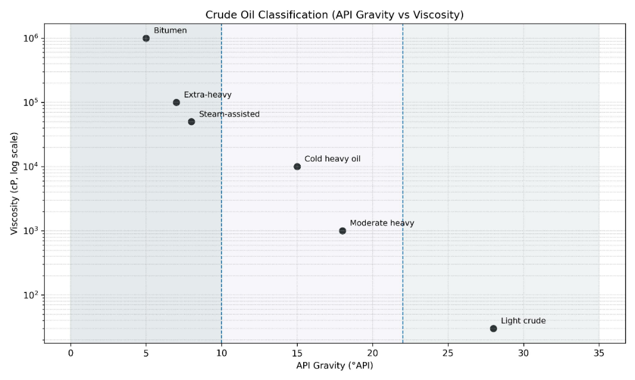
Fig. 1. Practical classification map for heavy and extra-heavy crude oils, based on literature synthesis from [1], [4].

4.2 Viscosity and Temperature Dependence
If a single property drives the most engineering decisions across the heavy-crude value chain, it is viscosity. Viscosity controls whether the oil moves through reservoir rock at meaningful rates, whether pipeline transport is feasible without treatment, what heating duty is required, and what blend ratio is needed for dilution [2], [5]. The Arrhenius-type relationship between viscosity and temperature is fundamental: the natural logarithm of viscosity is approximately proportional to the inverse of absolute temperature. For bitumen at 15 degrees Celsius, viscosity may reach 5 to 10 million centipoise. At 200 degrees Celsius, the same bitumen exhibits viscosity of only a few hundred centipoise [4], [9]. That change of approximately four orders of magnitude over 185 degrees is the engineering opportunity that every thermal recovery method exploits. Fig. 2 illustrates this temperature dependence across four crude categories.
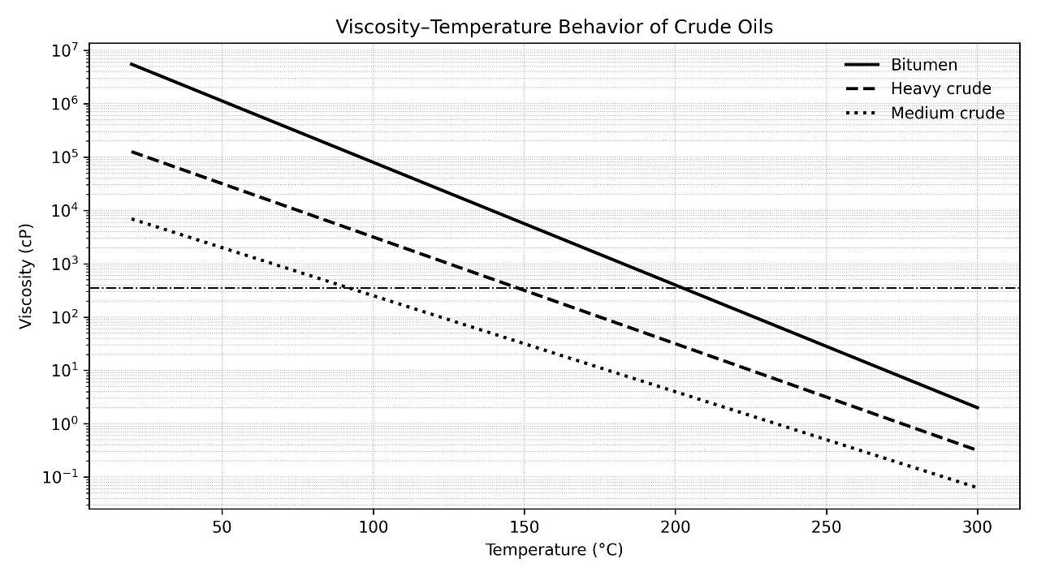
Fig. 2. Temperature dependence of viscosity for each crude category, showing CSS and SAGD operating zones [4], [8].

4.3 SARA Composition and Contaminants
The most important compositional framework for heavy oil is SARA fractionation, which separates the crude into four chemical families: Saturates, Aromatics, Resins, and Asphaltenes. Heavy and extra-heavy crudes are systematically shifted toward the polar, high-molecular-weight end of this spectrum [1], [3]. Asphaltenes increase viscosity, worsen stability margins, and intensify fouling and deposition risk. Higher sulfur and nitrogen content increases hydrotreating severity, while nickel and vanadium shorten catalyst life. Conradson carbon residue (CCR) points to a heavier burden on vacuum distillation and bottoms-conversion units. These are not abstract laboratory details; they directly determine whether a refinery can accept the feed without major penalties.
Temperature sensitivity is another decisive issue. A modest temperature rise can dramatically reduce viscosity, which is why heat is the backbone of many heavy-oil operations. However, temperature management is expensive, water-intensive in steam systems, and strongly tied to emissions intensity [4], [8]. Thermal methods must therefore always be judged against surface fuel, water treatment, and carbon constraints. Table 1 summarizes the key property indicators that control heavy-oil handling throughout the value chain.
Table 1. Fluid properties that control heavy-oil handling and processing.
Property | Conventional Crude | Heavy Crude | Extra-Heavy Oil / Bitumen
API Gravity (°API) | > 22.3 | 10 – 22.3 | < 10
Density (kg/m³ at 15°C) | 800 – 920 | 920 – 1000 | ≥ 1000
Viscosity at reservoir temperature (cP) | < 100 | 100 – 10,000 | 10,000 to ≥10⁶
Asphaltene Content (wt%) | 0.1 – 5 | 5 – 15 | 10 to ≥25
Sulfur Content (wt%) | 0.1 – 2 | 1 – 5 | 3 – 7
Nickel + Vanadium (ppm) | 0 – 50 | 50 – 200 | 100 to ≥500
Conradson Carbon Residue, CCR (wt%) | 0 – 5 | 5 – 15 | 10 to ≥ 25

5. RECOVERY TECHNOLOGIES AND SELECTION WINDOWS
Heavy-oil recovery methods differ because they attack different bottlenecks. Some methods lower viscosity by heating the fluid, some reduce intermolecular resistance with solvents, some exploit geomechanical and foamy-oil behavior, and some chemically or catalytically modify the oil in situ [4], [8]. The correct choice depends less on popularity and more on the specific control variable of the reservoir.

5.1 Cold Production and CHOPS
Cold Heavy Oil Production with Sand (CHOPS) is most relevant in shallow, unconsolidated heavy-oil reservoirs where sand production and foamy-oil behavior can sustain surprisingly high production rates without thermal input [4]. The attraction of CHOPS is clear: relatively low initial capital, no steam generation system, and rapid deployment. The weakness is equally clear: lower ultimate recovery than well-executed thermal projects, substantial sand-handling requirements, progressive cavity growth around the wellbore, and limited applicability outside the right geomechanical setting. CHOPS is not a universal solution, but in the right reservoir it remains one of the most economically resilient starting points.

5.2 Cyclic Steam Stimulation (CSS)
Cyclic Steam Stimulation is a classic thermal method built on a three-phase sequence: steam injection, soak, and production [4]. The main value of CSS lies in its operational flexibility and in its ability to stimulate wells before a full continuous steam scheme is justified. CSS can work in thicker reservoirs with sufficient vertical containment, but its recovery efficiency is often constrained by steam override, uneven heating, and declining incremental performance after repeated cycles [8].

5.3 Steam-Assisted Gravity Drainage (SAGD)
Steam-Assisted Gravity Drainage is the benchmark recovery technology for deep, thick, laterally continuous bitumen reservoirs [4], [9]. By using a steam injector above a horizontal producer, SAGD creates a steam chamber that mobilizes bitumen and lets gravity drive it to the lower well. SAGD transforms a highly viscous resource into a continuously drained flow system with better sweep and higher recovery than cyclic processes. The limitations of SAGD are serious: large steam and water-treatment footprints, significant natural gas demand for steam generation, sensitivity to shale barriers and reservoir heterogeneity, high startup capital, and carbon-intensity concerns when the steam-to-oil ratio (SOR) is poor [9]. Recovery factors of 40 to 72 percent are achievable in good-quality reservoirs.

5.4 Solvent-Assisted SAGD and ES-SAGD
Enhanced solvent-assisted SAGD variants address the primary criticism of classical SAGD: excessive energy and water per barrel. By co-injecting light hydrocarbons or non-condensable gases with steam, these processes aim to reduce steam requirements, improve chamber conformance, and decrease residual oil saturation [8], [9]. They are particularly attractive where carbon intensity and water use are strategic constraints. The main challenges are operational control, solvent retention, and the economics of solvent recovery and recycle.

5.5 VAPEX and Solvent-Dominant Methods
Purely solvent-based recovery methods such as VAPEX (Vapor Extraction) or cyclic solvent injection are conceptually attractive because they reduce thermal demand and can operate where steam is difficult or environmentally restricted [9]. Their weakness is slow mass transfer and longer response time compared with steam-dominant systems. In many real projects, the most promising role for solvents is therefore not to fully replace steam but to complement it by reducing the steam-to-oil ratio, improving mobility control, or lowering the intensity of thermal operations.

5.6 In-Situ Combustion, THAI, and CAPRI
In-situ combustion (ISC) and THAI/CAPRI-type concepts pursue a different logic: instead of importing all process heat from the surface, they generate part of the thermal driving force inside the reservoir [4], [11]. This creates the possibility of simultaneous recovery and partial upgrading. In theory, this is highly attractive for extra-heavy oils. In practice, combustion-front control, oxygen management, heterogeneity, operational risk, and scale-up uncertainty have limited widespread adoption. Even so, combustion-based technologies remain strategically important because they may offer a route where water is scarce and in-reservoir upgrading is valuable.

5.7 Emerging Hybrid Technologies
Emerging techniques including electromagnetic heating, ultrasound, nanomaterial-assisted aquathermolysis, catalytic additives, and hybrid chemical-thermal schemes should not be dismissed as academic curiosities [7], [10], [12]. Their real importance is that they target the next generation of heavy-oil projects, where incremental gains in steam efficiency, viscosity reduction, and partial upgrading may matter more than a completely new recovery philosophy. At present, most of these approaches are better viewed as enhancement tools rather than stand-alone universal methods. Fig. 3 illustrates the SAGD well-pair configuration and steam-chamber geometry that underpins most commercial deep-bitumen developments, and Fig. 4 combines a schematic of the CHOPS wormhole-and-foamy-oil mechanism with a summary of reported recovery factor ranges across all reviewed methods.
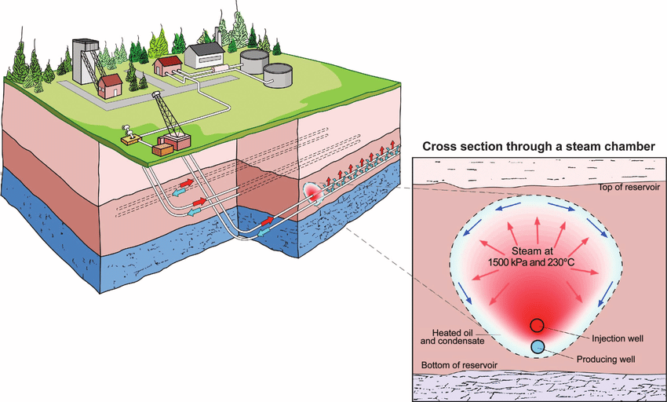
Fig. 3. Steam-Assisted Gravity Drainage (SAGD) well pair configuration showing the steam chamber and gravity drainage mechanism, adapted from [4], [9].
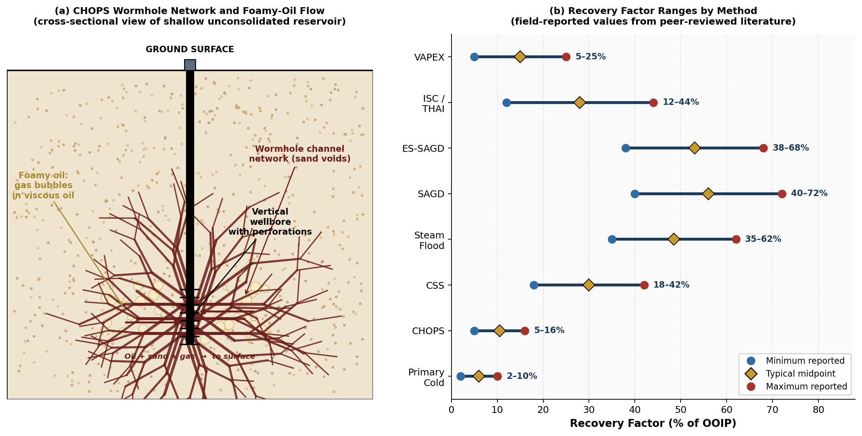
Fig. 4. (a) CHOPS wormhole network and foamy-oil flow schematic; (b) recovery factor ranges by method [4], [8], [9].
Table 2. Comparison of major heavy-oil recovery routes.
Route | Primary Mechanism | Typical Liquid Yield | Hydrogen Requirement | Main Limitation | Best Application
Visbreaking | Mild thermal cracking for viscosity reduction | 95% | None | Only modest upgrading; limited improvement in product quality | Residue conditioning and pre-upgrading before further conversion
Delayed Coking | Severe thermal cracking with carbon rejection | 70–80% | None | Produces substantial coke, typically 20–30 wt% of feed | Primary upgrading where hydrogen is limited or costly
Solvent Deasphalting | Selective rejection of asphaltenes and metals by solvent extraction | 55–70% | None | Asphalt disposal and limited direct conversion | Feed pretreatment ahead of hydrocracking or FCC-oriented upgrading
Hydrotreating | Heteroatom removal by catalytic hydrogenation | 95% | Moderate | Improves quality but does not provide deep conversion by itself | Finishing naphtha, kerosene, and gas-oil streams
Mild Hydrocracking | Partial hydrogen-addition conversion | 78–85% | High | Catalyst sensitivity to metals and residue contaminants | Partial upgrading to transport or refinery acceptance specifications
Full Hydrocracking | Deep hydrogen-addition conversion | 85–92% | Very high | High capital cost and large hydrogen demand | Premium upgrading for high-quality synthetic crude

6. TRANSPORTATION AND FLOW ASSURANCE
Transportation is often the silent project killer in heavy-oil development. An oil that can be produced is not automatically exportable. Pipeline systems impose limits on viscosity, pour behavior, pressure drop, emulsion stability, temperature loss, and asphaltene compatibility [2], [5], [6]. Midstream design must therefore begin during recovery selection rather than after field development is already committed.

6.1 Dilution and Dilbit
Diluent blending is the most widely adopted solution because it is simple and commercially proven. Light hydrocarbons such as condensate or naphtha reduce viscosity sharply and enable pipeline movement as diluted bitumen (dilbit) or synthetic-crude bitumen (synbit) blends [2], [13]. The target specifications for most Canadian heavy-crude pipelines are viscosity below 350 centistokes and density below 940 kilograms per cubic meter at operating temperature. Achieving these specifications for Athabasca bitumen typically requires a blend ratio of approximately 30 to 40 volume percent diluent. The economic penalty is significant: the diluent must be purchased, transported to the production site, blended in, shipped with the bitumen, and then recovered and returned.

6.2 Heated Pipelines
Heated pipelines remove the need for as much diluent but impose energy cost, thermal insulation requirements, and operability risks during shutdown [5], [13]. The energy intensity is significant, typically 10 to 50 watts per meter depending on ambient conditions, insulation quality, and required temperature differential. For subsea applications, electrically heated flexible pipe and bundled systems have been developed specifically for deepwater heavy-crude fields.

6.3 Emulsification and Core-Annular Flow
Oil-in-water emulsification creates a dispersed phase where heavy-oil droplets are surrounded by a continuous water phase, dramatically reducing the apparent viscosity of the flowing mixture [14]. The tradeoff is that the emulsion chemistry must be carefully managed throughout transport, and downstream separation at the receiving facility adds cost and complexity. Core-annular flow is a related concept where heavy oil flows as a central core through the pipe while water forms a thin lubricating annulus against the pipe wall [2]. The water carries the friction load, and since water has very low viscosity compared to heavy crude, the pumping energy requirement drops substantially.

6.4 Partial Upgrading for Transport
Partial upgrading deserves special emphasis because it simultaneously addresses transportability and refinery acceptance [3], [5]. By modestly increasing API gravity, lowering viscosity, and reducing the fraction of the heaviest residue, partial upgrading can reduce diluent demand and improve netback value. For remote projects or projects constrained by condensate supply, this can be a stronger strategic move than endlessly optimizing dilution alone. Fig. 5 presents a simplified process flow diagram comparing the three main transportation pathways, and Table 3 summarizes the main transport routes.
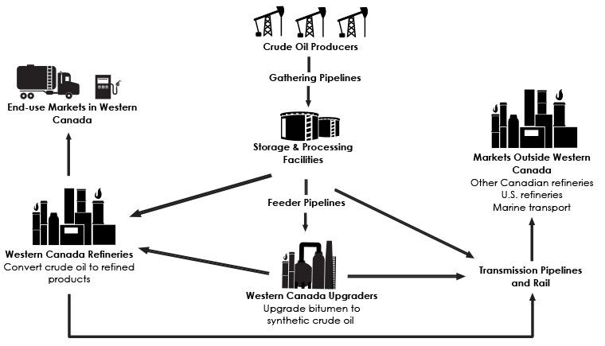
Fig. 5. Process flow diagram showing three alternative heavy-oil transportation pathways: dilution, heated pipeline, and partial upgrading, synthesized from [2], [5], [13].

Table 3. Main transportation routes for heavy and extra-heavy crude oils.
Transport Option | Main Benefit | Main Drawback
Dilution | Operationally mature; flexible | Diluent supply and round-trip logistics cost
Pipeline heating | Direct viscosity control without blending | Energy intensive at long distances
Emulsification | Reduces apparent viscosity significantly | Downstream emulsion separation required
Core-annular flow | Large friction reduction potential | Narrow stable operating envelope
Partial upgrading | Eliminates diluent; improves refinery fit | Capital cost of upgrading unit required

7. UPGRADING TECHNOLOGIES
Once heavy oil reaches a processing center, the next question is how much of the burden should be removed before the main refinery conversion train. Upgrading routes can be divided into carbon-rejection pathways and hydrogen-addition pathways [3]. The choice between these two fundamental categories depends on feed quality, hydrogen availability, capital budget, and the receiving refinery configuration.

7.1 Carbon-Rejection Routes
Carbon rejection works by selectively discarding the heaviest, most carbon-rich molecules and collecting the lighter material that remains. Visbreaking, delayed coking, flexicoking, and solvent deasphalting (SDA) fall into this category [3]. These processes are robust choices when the feed is extremely residue rich. Their drawback is that they shift part of the problem into coke, pitch, or deasphalted-bottoms handling.
Delayed coking is the most widely deployed commercial upgrading technology in oil sands operations. Vacuum residue is heated to approximately 490 to 510 degrees Celsius and fed to large cylindrical coke drums where thermal cracking reactions occur over 16 to 24 hours of residence time. Lighter cracked liquids rise and are recovered as synthetic-crude components, while petroleum coke accumulates in the drum. The main limitation is that coke is produced at 20 to 30 weight percent of feed, and the market for high-sulfur petroleum coke is shrinking.

7.2 Hydrogen-Addition Routes
Hydrogen-addition routes such as hydrotreating, hydrocracking, ebullated-bed hydrocracking, and slurry hydroconversion aim to improve liquid yield and product quality more directly [3], [12]. Their strength is higher conversion to valuable lighter fractions and stronger heteroatom removal. Hydrocracking achieves liquid yields of 85 to 92 percent on a volume basis, dramatically exceeding delayed coking. The weakness is that these methods require hydrogen, high pressure, severe catalysts, and more complex residue management. For many refineries, the limiting factor is not only reaction technology but hydrogen network capacity and sulfur-recovery infrastructure.
Ebullated-bed reactors such as H-Oil and LC-Fining use a bed of catalyst particles in continuous boiling motion maintained by upward liquid and gas flow. This allows continuous catalyst addition and withdrawal, which is critical for feeds with very high metals content that would rapidly plug a fixed-bed catalyst. Slurry hydrocracking goes further by dispersing catalyst as very fine particles in the liquid feed, eliminating bed plugging concerns and allowing processing of the most refractory residue feeds [12]. Fig. 6 shows a simplified process flow diagram contrasting the two principal upgrading pathways: carbon rejection through delayed coking and hydrogen addition through hydrocracking.
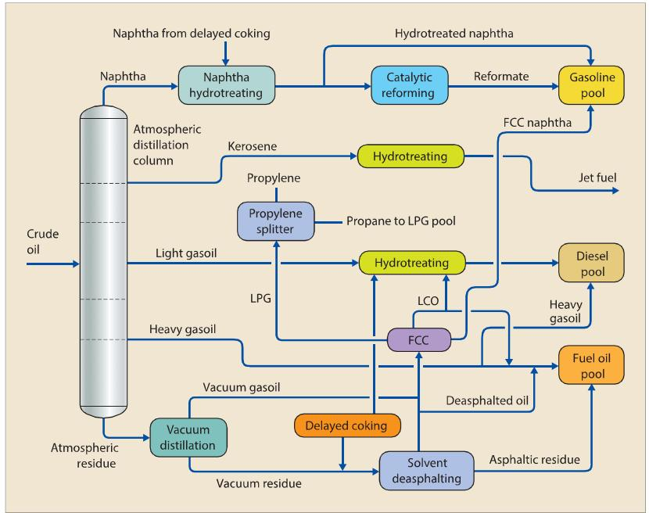
Fig. 6. Simplified process flow diagram of the two principal heavy-oil upgrading pathways: delayed coking (carbon rejection) and hydrocracking (hydrogen addition), based on [3], [12].

Table 4. Upgrading pathways and their main use cases.
Property | Conventional Crude | Heavy Crude | Extra-Heavy Oil / Bitumen | Engineering Significance
API Gravity (°API) | 22 – 45 | 10 – 22.3 | < 10 | Governs distillation yield; lower API increases residue fraction and reduces light product yield
Density (kg/m³ at 15°C) | 800 – 920 | 920 – 1000 | 1000 – 1050 | High density increases handling difficulty; bitumen approaches or exceeds water density
Viscosity at reservoir conditions (cP) | < 100 | 100 – 10,000 | > 10,000 | Determines need for thermal recovery
Asphaltenes (wt%) | 0.1 – 5 | 5 – 15 | 10 – 25 | Causes fouling, instability, and coke formation in upgrading units
Sulfur (wt%) | 0.1 – 2 | 1 – 5 | 3 – 7 | Requires extensive hydrotreating and sulfur recovery
Nickel + Vanadium (ppm) | 0 – 50 | 50 – 200 | 100 – 500 | Catalyst poisoning in FCC/hydro processing; requires guard beds
Conradson Carbon Residue (wt%) | 0 – 5 | 5 – 15 | 10 – 25 | Indicates coke-forming tendency; critical for coking vs hydro processing decisions

8. REFINERY PROCESSING IMPLICATIONS
For refinery operations, heavy and extra-heavy crude oils change almost every major balance in the plant. Distillation yields shift toward vacuum residue, crude heaters face stronger coking and fouling tendency, desalting becomes more demanding, and downstream conversion units carry more of the value-creation burden [3]. Put simply, heavy oil reduces the share of value that can be obtained from straight-run separation and increases the share that must be created by conversion. This immediately elevates the importance of delayed coking, resid hydrocracking, hydrotreating, hydrogen production, amine treating, Claus sulfur recovery, and tail-gas cleanup.

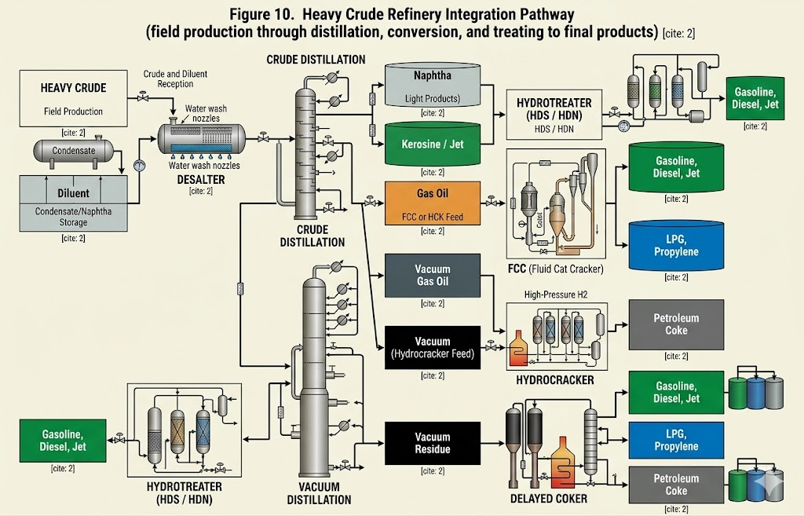
Fig. 7. Heavy crude refinery integration pathway showing flow from field production through distillation, conversion, and treating to final products [3].

Heavy crudes carry more water, dissolved salts, and suspended solids than light crudes, and their higher viscosity makes demulsification slower in electrostatic desalters. Multiple desalting stages with preheating to 80 to 120 degrees Celsius and demulsifier chemical injection are typically needed. Inadequate desalting is one of the most damaging operational failures in a refinery processing heavy crude because chloride hydrolysis in the crude-column overhead system creates hydrochloric acid that causes aggressive corrosion.
The atmospheric distillation unit separates the feed by boiling point into naphtha, kerosene, gas oil, and atmospheric residue. For a 12-degree-API heavy crude, atmospheric residue yield is 65 to 75 percent of feed, compared to 25 to 35 percent for a 35-degree-API light crude. That difference completely changes the refinery economics. The majority of the crude value must be created through conversion rather than recovered through separation. Vacuum distillation of the atmospheric residue produces vacuum gas oil as the primary FCC and hydrocracker feed, and vacuum residue as the most challenging fraction.
Fluid Catalytic Cracking (FCC) converts vacuum gas oil to gasoline, LPG, and light cycle oil using zeolite catalysts at 500 to 540 degrees Celsius. For heavy-crude-derived vacuum gas oil, the elevated nickel and vanadium concentrations are the central concern. Nickel deposits on the FCC catalyst and promotes dehydrogenation, generating excess hydrogen and coke at the expense of gasoline yield [3]. Vanadium attacks the zeolite structure directly and causes permanent catalyst deactivation. Refineries handling heavy-crude vacuum gas oil respond by using metals-trapping catalyst additives, adding fresh catalyst at higher daily rates, and pretreating the vacuum gas oil through a hydrotreater before FCC.
A refinery processing heavy crude requires 500 to 1,500 standard cubic meters of hydrogen per cubic meter of crude processed. This demands large steam methane reforming plants and complex hydrogen distribution networks. Every refinery handling heavy crude also needs an integrated sulfur management train. Hydrogen sulfide generated in hydroprocessing units is captured by amine treating systems, recovered as a concentrated acid gas stream, and converted to elemental sulfur in a Claus plant. For a refinery processing 5 weight percent sulfur crude at 100,000 barrels per day, the sulfur recovery system handles thousands of tonnes of elemental sulfur per year.

9. INTEGRATED THREE-GATE SELECTION FRAMEWORK

9.1 The Three Gates
The distinctive analytical contribution of this report is a three-gate selection framework. Gate 1 asks whether the reservoir is technically compatible with the recovery mechanism. This includes depth, net pay, continuity, pressure support, unconsolidated sand behavior, heterogeneity, and water sensitivity. A method that does not pass Gate 1 should be rejected early regardless of other merits.
Gate 2 asks whether the surface and logistics system can sustain the selected method: steam generation, water treatment, fuel gas, solvent recycle, diluent access, export pipeline limits, and ambient heat loss. A method that passes Gate 1 but fails Gate 2 is technically possible but commercially unviable.
Gate 3 asks whether the downstream system can absorb the produced material: residue-conversion severity, hydrogen capacity, sulfur handling, metals tolerance, and product-slate objectives. A method that passes Gates 1 and 2 but fails Gate 3 produces oil that cannot be profitably processed. Fig. 8 presents the complete framework.
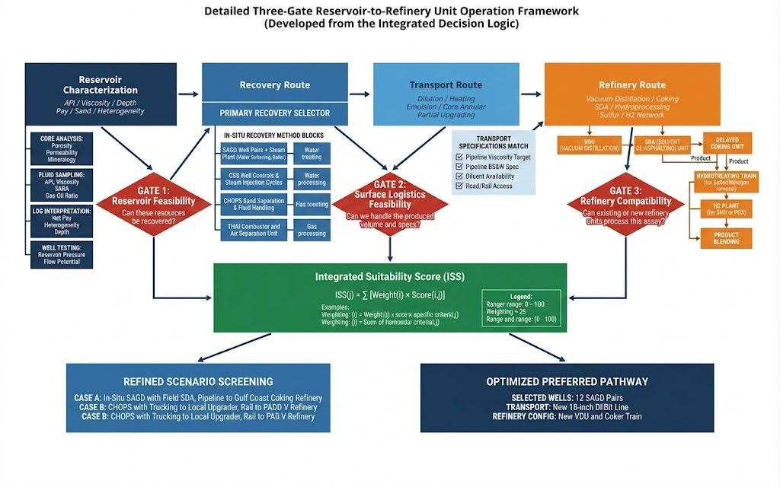
Fig. 8. Three-gate reservoir-to-refinery selection framework developed in this report.

9.2 Integrated Suitability Score (ISS) Equation
To make the framework quantitative, a weighted Integrated Suitability Score is used:
$$ISS(j)=\sum_{i=1}^{n}{w_{i}} s_{i,j}$$
where:
- $j$denotes the candidate method or pathway under evaluation,
- $i$represents each criterion within the evaluation set,
- $w_{i}$is the weight assigned to criterion $i$, expressed as a fraction of the total (such that $∑w_{i}=1$),
- $s_{i,j}$is the performance score of method $j$with respect to criterion $i$, evaluated on a scale from 1 to 5, where 5 corresponds to the most favorable outcome.
The weighting system is adjustable to project priorities. If the dominant objective is maximizing recovery factor, the recovery potential criterion receives the highest weight. If the objective is minimizing logistics cost, transportability and diluent independence receive higher weight. If carbon intensity is a regulatory or social-license constraint, GHG intensity and steam requirement receive the highest weights. Table 5 provides suggested default weights for a general-purpose screening application.
Table 5. Suggested weights for the Integrated Suitability Score.
Criterion | Suggested Weight | Reason for Inclusion
Reservoir technical fit | 0.25 | Must match depth, pay, mobility, or continuity
Recovery performance potential | 0.15 | Ultimate recovery still matters but not alone
Surface utility requirement | 0.10 | Steam, water, solvent recycle, fuel gas can dominate feasibility
Export/transport fit | 0.15 | Viscosity control and pipeline access decide commercial success
Environmental intensity | 0.10 | Water, energy, and emissions increasingly constrain projects
Capital and operating complexity | 0.10 | Technically good methods may be impractical at scale
Refinery compatibility | 0.15 | Residue conversion, H2, sulfur handling, metals tolerance must be respected

10. SCENARIO-BASED APPLICATION
To demonstrate how the three-gate framework behaves, three representative project archetypes were screened. These cases are illustrative engineering scenarios constructed from conditions described in the literature; they are intended to demonstrate decision logic rather than to claim field-measured results. Fig. 9 presents the decision tree showing how each scenario follows a distinct path through the three gates and arrives at a different recommended pathway.

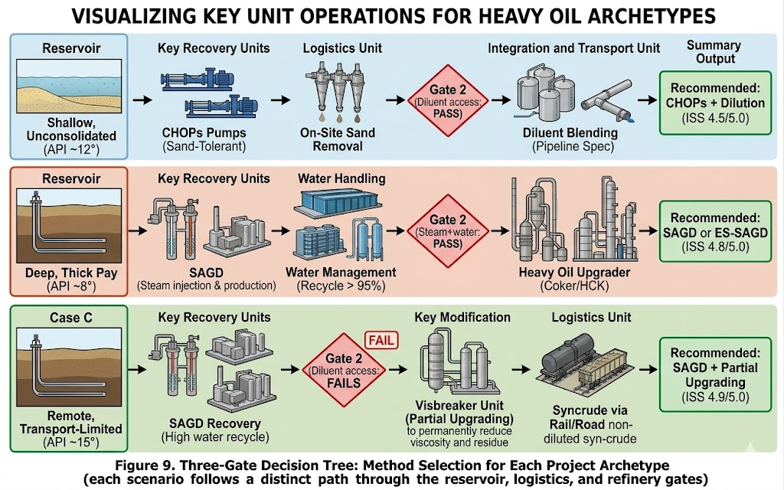
Fig. 9. Three-gate decision tree showing how the selection framework produces distinct recommended pathways for each of three contrasting project archetypes.

10.1 Case A: Shallow Unconsolidated Heavy Oil
Case A represents a shallow reservoir with heavy oil around 12 degrees API, viscosity in the several-thousand-centipoise range, unconsolidated sand, moderate solution gas, and strong sensitivity to capital cost. Under these conditions, CHOPS becomes attractive because it can exploit wormholing and foamy-oil behavior without the large infrastructure burden of steam-dominant methods [4]. Thermal follow-up such as CSS may become relevant later, but CHOPS is the natural first screen. The ISS score for CHOPS in Case A is 4.5 out of 5.0, while SAGD scores only 1.5 because the shallow depth and unconsolidated formation make horizontal-well geometry and steam containment very poor.

10.2 Case B: Deep Thick Bitumen with Continuous Pay
Case B represents an extra-heavy or bitumen-type system with very high viscosity, greater depth, and a thick laterally continuous pay zone. Here the preferred answer shifts toward SAGD and solvent-assisted SAGD because strong gravity drainage and thermal containment become more valuable than low initial capital [9]. The decisive variables are steam generation, water treatment, heat integration, and emissions intensity. SAGD scores 4.8 out of 5.0 in Case B, while CHOPS scores only 1.2 because the extreme viscosity and depth make cold production physically impossible.

10.3 Case C: Remote Transport-Limited Heavy Crude
Case C represents a producible heavy crude whose main difficulty lies in long-distance transport, limited access to diluent, and poor compatibility with the receiving refinery. In this situation, the recovery method alone does not solve the business problem. Partial upgrading combined with SAGD scores highest at 4.9 because it resolves both the transport constraint and the refinery mismatch simultaneously [3], [5]. Pure SAGD without upgrading scores only 3.2 because the produced bitumen cannot reach the market economically without solving the logistics and refinery-fit problems. Table 6 summarizes the outcomes across all three cases.
Table 6. Outcomes from the three-gate screening framework.
Project Archetype | Preferred Base Route | Reason | Supporting Choices
Shallow unconsolidated | CHOPS | Matches sand-drive; low capital | Dilution transport; coker-equipped refinery
Deep thick bitumen | SAGD or ES-SAGD | Strong gravity drainage; field maturity | Steam-solvent if carbon
Remote extra-heavy | SAGD + partial upgrading | Transport and refinery limits dominate | Partial upgrading eliminates diluent dependence

11. KEY FINDINGS AND DISCUSSION
The most important finding from this integrated review is that heavy-oil development must be optimized across the full value chain rather than at any single stage. Reservoir engineers, transport specialists, upgraders, and refinery process engineers often treat their own sub-problem as primary. The literature reviewed here shows that the better approach is integration [1], [3], [8]. The production method changes the transport requirement, the transport method changes the arriving crude, and the refinery configuration determines how much upgrading should have been done earlier. Fig. 10 presents an energy and carbon flow diagram that traces natural gas input, steam generation, reservoir operations, and upgrading together with quantified CO₂ emission streams, alongside a comparative bar summary of upstream intensity by crude type. SAGD in-situ operations produce approximately 44 kilograms of CO₂ equivalent per barrel, while oil sands surface mining produces approximately 58 kilograms per barrel. Both values are substantially higher than the 11 kilograms per barrel baseline for conventional light crude. Carbon capture and storage (CCS) integration can reduce this footprint by 50 to 60 percent at an incremental cost that becomes economic at carbon prices above approximately 80 Canadian dollars per tonne [10].

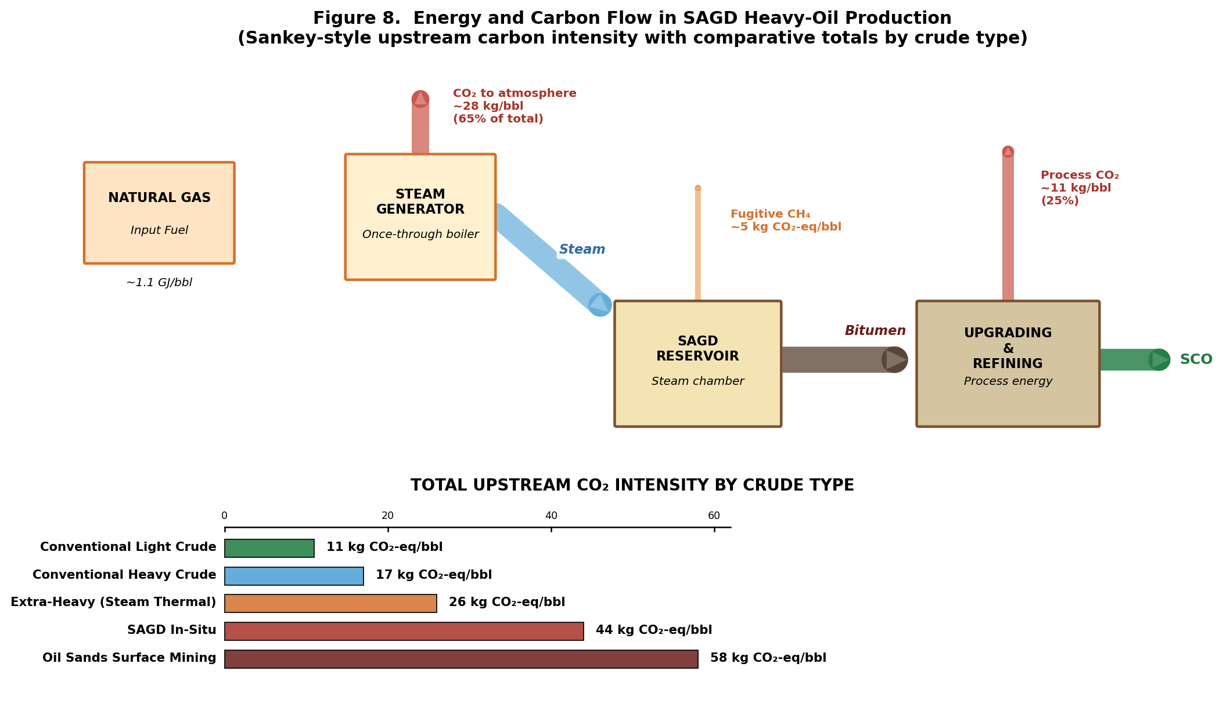
Fig. 10. Energy and carbon flow in SAGD heavy-oil production (Sankey-style) with comparative upstream CO₂ intensity by crude type [10], [20].

Based on the integrated review, several findings emerge clearly. First, thermal methods remain the industrial reference standard for deep, thick, laterally continuous bitumen reservoirs. Second, cold production remains highly competitive in the subset of shallow unconsolidated heavy-oil reservoirs that exhibit favorable foamy-oil and sand-drive behavior. Third, solvent-assisted methods are gaining strategic value because they directly address the steam, water, and emissions penalties that increasingly limit thermal projects. Fourth, transportation strategy should never be treated as a late-stage optimization problem. Fifth, refinery compatibility is often the hidden economic driver.

12. CONCLUSION
This project establishes that heavy and extra-heavy crude oils cannot be effectively developed using isolated, single-stage decision-making. Instead, they must be treated as integrated reservoir-to-refinery systems, where recovery method, transportation strategy, upgrading severity, and refinery processing capacity are tightly coupled.
The primary contribution of this work is the development of a three-gate selection framework, supported by a quantitative Integrated Suitability Score (ISS), which enables structured comparison of recovery and upgrading pathways across the full value chain. Unlike conventional approaches that evaluate technologies independently, this framework enforces a sequential screening logic based on:
- reservoir feasibility,
- surface and logistics constraints, and
- refinery compatibility.
Application of this framework to three representative engineering scenarios demonstrates that technology selection is highly sensitive to system-level constraints. The results show that:
- CHOPS emerges as the optimal solution in shallow, unconsolidated reservoirs due to favorable sand-drive mechanisms and low capital requirements,
- SAGD and solvent-assisted variants dominate in deep, thick bitumen reservoirs where thermal recovery is the only viable mobilization mechanism,
- SAGD combined with partial upgrading becomes the preferred pathway in transport-limited systems, where diluent availability and refinery compatibility control overall project feasibility.
More importantly, this work shows that recovery selection alone is insufficient. A method that performs well at the reservoir level may fail due to transportation limitations or refinery constraints. The framework developed in this report addresses this gap by linking upstream, midstream, and downstream decisions into a single evaluation structure.
The Integrated Suitability Score further strengthens this approach by converting qualitative engineering judgment into a transparent, adjustable decision metric, allowing the framework to be adapted to different project priorities such as recovery efficiency, cost, environmental impact, or refinery limitations.
Overall, this project moves beyond descriptive comparison and provides a practical engineering screening tool that can support real-world heavy-oil development decisions by ensuring that all critical constraints across the value chain are evaluated simultaneously.

13. LIMITATIONS
This report is deliberately integrative, but it has clear limitations. First, it is a literature-driven technical synthesis rather than a field-specific simulation study. It does not include numerical reservoir simulation, steam-chamber growth modeling, pipeline hydraulics, or refinery linear programming optimization for a named asset.
Second, many published recovery factors and steam-to-oil ratios are field-dependent, so any comparative number should be treated as indicative rather than universally transferable [4], [9]. Environmental performance varies strongly with local fuel, electricity, water-recycle efficiency, and solvent losses; therefore, no single emissions conclusion should be generalized without project-specific data [10].
Third, the ISS scores and criterion weights used in the three case studies are illustrative. They are calibrated to the qualitative descriptions of each case scenario and supported by quantitative ranges from the literature, but they are not derived from proprietary field data or formal sensitivity analysis. Any real-project application of the framework would require project-specific calibration.
Fourth, some of the technologies reviewed here, particularly electromagnetic heating, dispersed catalyst approaches, and supercritical water processing, are at pilot or pre-commercial scale. The confidence in their performance scores in the ISS is lower than for commercially mature methods, and that uncertainty is not explicitly propagated through the scoring in this version of the framework.

14. FUTURE DIRECTIONS
Future work should move this topic from screening to asset-specific design. The most direct next step would be converting the ISS framework into a quantitative software tool implemented in MATLAB or Python. A quantitative implementation would allow users to input project-specific property data and receive ranked method comparisons with sensitivity analysis showing how the preferred selection changes as oil price, natural gas price, carbon price, and diluent cost vary.
A second extension would be connecting the framework to actual crude assay data. This would allow quantitative yield calculations from the distillation tower through to specific upgrading-unit sizing, transforming the qualitative comparison of Table 4 into a quantitative product-yield and refinery-economics model.
A third direction would be a dedicated study comparing conventional steam-only SAGD, solvent-assisted SAGD, and electrically heated SAGD under different carbon price scenarios. This would quantify the exact crossover point at which each approach becomes economically preferred and is directly relevant to active research programs at major oil sands operators.
A fourth direction would be a detailed economic model comparing full dilution, partial upgrading, and refinery residue-conversion strategies for a single heavy-oil supply chain. Partial upgrading fundamentals have been examined in recent literature [3], [5], but a project-specific quantitative analysis linked to real diluent pricing and pipeline tariff structures would be more actionable.
A fifth direction would be a refinery configuration matching study that pairs specific heavy-crude feedstock properties with specific refinery-configuration types and quantifies the economic improvement when crude selection and refinery configuration are optimized together.

15. REFERENCES
[1] R. G. Santos, W. Loh, A. C. Bannwart, and O. V. Trevisan, "An overview of heavy oil properties and its recovery and transportation methods," Brazilian Journal of Chemical Engineering, vol. 31, no. 3, pp. 571-590, 2014. doi: 10.1590/0104-6632.20140313s00001853.
[2] R. Martinez-Palou, M. de L. Mosqueira, B. Zapata-Rendon, E. Mar-Juarez, C. Bernal-Huicochea, J. de la Cruz Clavel-Lopez, and J. Aburto, "Transportation of heavy and extra-heavy crude oil by pipeline: A review," Journal of Petroleum Science and Engineering, vol. 75, no. 3-4, pp. 274-282, Jan. 2011. doi: 10.1016/j.petrol.2010.11.020.
[3] M. S. Rana, V. Samano, J. Ancheyta, and J. A. I. Diaz, "A review of recent advances on process technologies for upgrading of heavy oils and residua," Fuel, vol. 86, no. 9, pp. 1216-1231, Jun. 2007. doi: 10.1016/j.fuel.2006.08.004.
[4] K. Guo, H. Li, and Z. Yu, "In-situ heavy and extra-heavy oil recovery: A review," Fuel, vol. 185, pp. 886-902, Dec. 2016. doi: 10.1016/j.fuel.2016.08.047.
[5] A. Hart, "A review of technologies for transporting heavy crude oil and bitumen via pipelines," Journal of Petroleum Exploration and Production Technology, vol. 4, no. 3, pp. 327-336, Sep. 2014. doi: 10.1007/s13202-013-0086-6.
[6] F. Souas, N. Safri, A. Benmounah, A. Khalfallah, and B. Mecheri, "A review on the rheology of heavy crude oil for pipeline transportation," Petroleum Research, vol. 6, no. 2, pp. 116-136, Jun. 2021. doi: 10.1016/j.ptlrs.2020.11.001.
[7] M. Ahmadi and Z. Chen, "Challenges and future of chemical assisted heavy oil recovery processes," Advances in Colloid and Interface Science, vol. 275, p. 102081, Jan. 2020. doi: 10.1016/j.cis.2019.102081.
[8] S. Gomaa, K. G. Salem, and A. N. El-hoshoudy, "Enhanced heavy and extra heavy oil recovery: Current status and new trends," Petroleum, vol. 10, no. 3, pp. 399-410, Sep. 2024. doi: 10.1016/j.petlm.2023.10.001.
[9] I. D. Gates and S. R. Larter, "Energy efficiency and emissions intensity of SAGD," Fuel, vol. 115, pp. 706-713, Jan. 2014. doi: 10.1016/j.fuel.2013.07.073.
[10] B. Nimana, C. Canter, and A. Kumar, "Life cycle assessment of greenhouse gas emissions from Canada's oil sands-derived transportation fuels," Energy, vol. 88, pp. 544-554, Aug. 2015. doi: 10.1016/j.energy.2015.05.078.
[11] M. Varfolomeev, C. Yuan, A. Bolotov, M. A. Khelkhal, I. Rodionov, A. Suwaid, A. S. Vakhitov, A. I. Sharifullin, T. Al-Muntaser, and M. Saleh, "Effect of copper stearate as catalysts on the performance of in-situ combustion process for heavy oil recovery and upgrading," Journal of Petroleum Science and Engineering, vol. 207, p. 109125, Dec. 2021. doi: 10.1016/j.petrol.2021.109125.
[12] M. Lam-Maldonado, J. A. Melo-Banda, D. Macias-Ferrer, and P. Schacht, "NiFe nanocatalysts for the hydrocracking heavy crude oil," Catalysis Today, vol. 349, pp. 159-167, Jun. 2020. doi: 10.1016/j.cattod.2018.08.005.
[13] A. Saniere, I. Henaut, and J. F. Argillier, "Pipeline transportation of heavy oils, a strategic, economic and technological challenge," Oil & Gas Science and Technology, vol. 59, no. 5, pp. 455-466, Sep. 2004. doi: 10.2516/ogst:2004031.
[14] D. Langevin, J. F. Argillier, and B. Herzhaft, "Crude oil emulsion properties and their application to heavy oil transportation," Oil & Gas Science and Technology, vol. 59, no. 5, pp. 511-521, Sep. 2004. doi: 10.2516/ogst:2004036.
[15] U.S. Geological Survey, "Orinoco Oil Belt, Venezuela: Assessment of technically recoverable oil resources," USGS Fact Sheet 2009-3028, 2009. [Online]. Available: https://pubs.usgs.gov/fs/2009/3028
[16] Government of Alberta, "Oil sands facts and statistics," 2025. [Online]. Available: https://www.alberta.ca/oil-sands-facts-and-statistics
[17] J. G. Speight, The Chemistry and Technology of Petroleum, 5th ed. Boca Raton, FL, USA: CRC Press, 2014.
[18] M. R. Gray, Upgrading Oilsands Bitumen and Heavy Oil. Edmonton, AB, Canada: University of Alberta Press, 2015.
[19] R. M. Butler, Thermal Recovery of Oil and Bitumen. Calgary, AB, Canada: GravDrain Inc., 1991.
[20] A. D. Charpentier, J. A. Bergerson, and H. L. MacLean, "Understanding the Canadian oil sands industry's greenhouse gas emissions," Environmental Research Letters, vol. 4, no. 1, p. 014005, Jan. 2009. doi: 10.1088/1748-9326/4/1/014005.
[21] B. H. Pratama, T. Babadagli, and H. A. Li, "A review of the mechanics of heavy-oil recovery by steam injection methods," Journal of Petroleum Science and Engineering, vol. 217, p. 110854, Oct. 2022. doi: 10.1016/j.petrol.2022.110854.
[22] D. Manfre Jaimes, I. D. Gates, and M. Clarke, "Reducing the energy and steam consumption of SAGD through cyclic solvent co-injection," Energies, vol. 12, no. 20, p. 3860, Oct. 2019. doi: 10.3390/en12203860.
[23] X. Dong, H. Liu, J. Hou, and Y. Sun, "Enhanced oil recovery techniques for heavy oil and oil sands reservoirs after steam injection," Applied Energy, vol. 239, pp. 1190-1211, Apr. 2019. doi: 10.1016/j.apenergy.2019.01.244.
[24] L. C. Castaneda, J. A. D. Munoz, and J. Ancheyta, "Current situation of emerging technologies for upgrading of heavy oils," Catalysis Today, vol. 220-222, pp. 248-273, Mar. 2014. doi: 10.1016/j.cattod.2013.05.016.
[25] G. Giachetta, M. Leporini, and B. Marchetti, "Economic and environmental analysis of a steam assisted gravity drainage (SAGD) facility for oil recovery from Canadian oil sands," Applied Energy, vol. 142, pp. 1-9, Mar. 2015. doi: 10.1016/j.apenergy.2014.12.081.

